Submitted to: -

Ma’am Anmol Bilal

Submitted by: -

F179434

F179440

F178178

Table of Contents

1. Document Version 4

2. Introduction 5

3. Business Opportunity 5

4. Problem Statement 6

5. Summary of Features 6

5.1. Database 6

5.2. Accounts 6

6. Product Overview 7

7. Diagrams 8

7.1 Use Case Diagram 8

7.2 High-Level and Expanded Use Cases 8

Expanded Use Case 9

Expanded Use Case 10

Expanded Use Case 10

Fully Dressed Use Case 11

Expanded Use Case 11

Expanded Use Case 12

7.3 Domain Model 13

7.4 Class & Object Diagram 14

7.5 Sequence Diagram 15

7.6 Activity & Collaboration Diagram 16

7.7 State Chart Diagram 18

8. Dependencies and Constraints 19

9. Cost and Pricing 19

10. Licensing and Installation 19

# Document Version

|  |  |  |  |
| --- | --- | --- | --- |
| **Version** | **Date** | **Description** | **Authors** |
| V1.0 |  | Initial Vision Document |  |
| V2.0 |  | Refined Vision Document |  |

# Introduction

The Quarantine management system (QMS) will be an integrated software that handles different directions of clinic workflows. It will be managing the smooth healthcare performance along with administrative, medical, legal and financial control. That is a cornerstone for the successful operation of the healthcare facility. The Quarantine center will be used for Covid-19. For identification of Corona virus and treatment of the infected people. This software will help the management team to be more efficient in handling the daily activities and registration and discharge of their corona patients.

# Business Opportunity

If we hadn’t before, the world is now realizing the importance of public health. We are building the Quarantine Management System on our Public Health Platform. Inspired by all those within the public health and healthcare community, our team is making QMS available to Public Health Jurisdictions at no cost. Our entire team is committed and ready to help people manage their public health response and operations during this time of unprecedented need.

# Problem Statement

Faisalabad needs a reasonable Quarantine Center where the patients are kept, taken care of, and discharged. That Quarantine Center requires a computer software package to facilitate the automation of many manual tasks.

**Description:** Our QMS will be registering covid-19 patients and saving the information of all the Covid-19 positive patients in their database. Information of the condition of patients will also be updated regularly. In this way, corona patients will be managed properly and their information will not be lost even after they get discharged or dead.

Our package will be produced in several releases.

We will take the determination criteria from user (patient) and show the rooms list for patient basing on the criteria. User can get checked for Corona Test and then we will book the room if there is accessibility of the rooms in our Quarantine Center. There are various sorts for application they are director, inn specialist and typical user.

Following are the activities accommodated every user:

**Normal user:**

* Can register for the website
* Book appointment for Corona Testing
* If he is a corona positive person, he can book the room

**Quarantine center Staff:**

* Can register for the site
* Can add/update the details of the hotel.

**Administrator:**

* Will approve the new quarantine details added to the application
* Can delete the user/quarantine details

# Summary of Features

# Database

Username, password, email, patient id, doctor id, room number, registration date, discharge date, invoice, bills, admin ID, admin password.

# Accounts

* Patient Registration (Register)
* Authentication Management (Login)

1. Modules

* Diagnosis
* Treatment Information
* Patient Invoice
* Bill
* Appointments
* Staff Information
* Rooms
* Medicine Maintenance
* Suppliers
* Burry the Dead Body

# Product Overview

|  |  |
| --- | --- |
| **Customer Benefits** | **Supporting Features** |
| Convenient, flexible access to Quarantine Center | Fast and user friendly interface and cooperative staff |
| Less time consuming | Fast and user friendly interface |
| User’s feasibility and ease. Patients can do Online Reservations | Available rooms and information easily available. |
| Quarantine staff can Manage Rooms | Database |
| Patients get their risks assessed | Diligent staff and imported equipment |
| Quarantine staff can Manage patient’s records | Database |
| Patients get support and monitored during quarantine | Database |
| Fast and efficient performance | Active connection with database |

# Diagrams

## Use Case Diagram

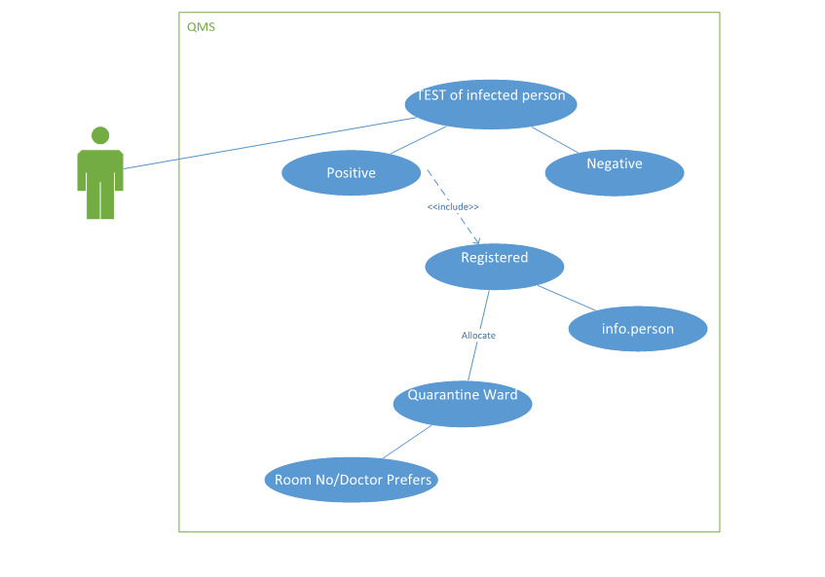

## High-Level and Expanded Use Cases

#### Register

|  |  |
| --- | --- |
| Use case name | Registration |
| Actor | Patient |
| Type | Primary |
| Description | Suspected person enters the COVID center and he register himself at desk then he is assigned a slip which holds its information |
| Pre-conditions | Person needs to physically visit the center. |
| Post-conditions | He will be Quarantined.  He will have Covid-19 test. |
| Normal flow | 1. Patient provide their details.  2. Staff saves the person’s details.  3. Staff then Patient details into the database.  4. Staff gives him a slip that that has Quarantine ward bed no and time of test. |
| Alternate Scenario | N/A |
|  |  |

### Expanded Use Case

#### Quarantine

|  |  |
| --- | --- |
| Use case name | Quarantine |
| Actor | Patient |
| Type | Primary |
| Description | After registration the patient needs to Quarantine in Quarantine wards until their test is done and get results. |
| Pre-conditions | Person needs to register first so that the staff can assign him a bed. |
| Post-conditions | He will have is test done. |
| Normal flow | 1. Patient will wait in Quarantine.  2. Patient will wait until his test is done.  3. He will be served with food and medication if any false condition occurs. |
| Alternate Scenario | N/A |

### Expanded Use Case

#### Test

|  |  |
| --- | --- |
| Use case name | Test |
| Actor | Patient |
| Type | Primary |
| Description | After waiting in Quarantine, he/she will be tested. The staff will take his/her sample. |
| Pre-conditions | He needs to be Quarantined. |
| Post-conditions | If patient is tested positive, he will be shifted to isolation ward.  If patient is tested negative, he will be discharged. |
| Normal flow | 1. Patient will be tested.  2. Staff will take samples.  3. Staff will take them to labs for results.  4. Patient is then treated according to results. |
| Alternate Scenario | N/A |

### Expanded Use Case

#### Positive

|  |  |
| --- | --- |
| Use case name | Positive |
| Actor | Infected Patient |
| Type | Primary |
| Description | If Registered and newly infected person have symptoms of COVID 19 then after taking his/her test. If result is positive, then our system gives id for patient and allocated room in isolation ward. |
| Pre-condition | Infected person must have some symptoms of COVID 19 before taking his/her test. |
| Post-condition | If infected person having positive report of his/her test. System give patient-id and room for patient. |
| Normal Flow | 1. Infected person must have some symptoms of COVID 19.  2. Then doing test.  3. If report will be positive.  4. System give Patient ID and allocated room in Isolation Ward. |
| Alternate  Scenario | N/A |

### Fully Dressed Use Case

#### Discharge

|  |  |
| --- | --- |
| Use case name | Discharge |
| Actor | Infected Patient |
| Type | Primary |
| Description | If infected person has symptoms of COVID 19 then we take his/her test. If result is negative, then he/she will be discharged. |
| Pre-condition | Infected person’s report should be negative. |
| Post-condition | If infected person has negative report of his/her test. He/she will be discharged. |
| Normal Flow | 1. Infected person must have some symptoms of COVID 19.  2. Then doing test.  3.If report will be negative, infected person will be discharged. |
| Alternate  Scenario | N/A |

### Expanded Use Case

#### Isolation

|  |  |
| --- | --- |
| Use case name | Isolation |
| Actor | Patient |
| Type | Primary |
| Description | User gets himself tested. System presents his result as positive if he has corona. Then system marked that user for isolation and assigns him a “patient id” and an isolation room. |
| Pre-conditions | Customer needs to get tested for COVID-19. |
| Post-conditions | System assigns user a patient id and isolation room number. |
| Normal flow | 1. User gets tested for CORONA. 2. System presents his result. He is tested positive. 3. System then save his name into the patient list into the database and assigns him a patient id. 4. System assigns him an isolation room. 5. System marks that isolation room as “booked”. |
| Alternate Scenario | N/A |

### Expanded Use Case

#### Negative

|  |  |
| --- | --- |
| Use case name | Isolation |
| Actor | User |
| Type | Primary |
| Description | User gets himself tested. System presents his result as negative and saves his data into database. And then mark that person as “out of the danger” list. |
| Pre-conditions | Customer needs to get tested for COVID-19. |
| Post-conditions | System marks the user out of the danger list. |
| Normal flow | 1. User gets tested for CORONA. 2. System presents his result. 3. User is tested “negative” for Corona. 4. System then save his name into the “negative tests” list into the database. 5. User is free to go. |
| Alternate Scenario | N/A |

## Domain Model

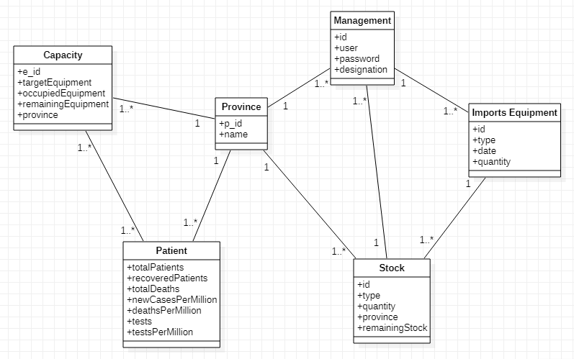

## Class & Object Diagram

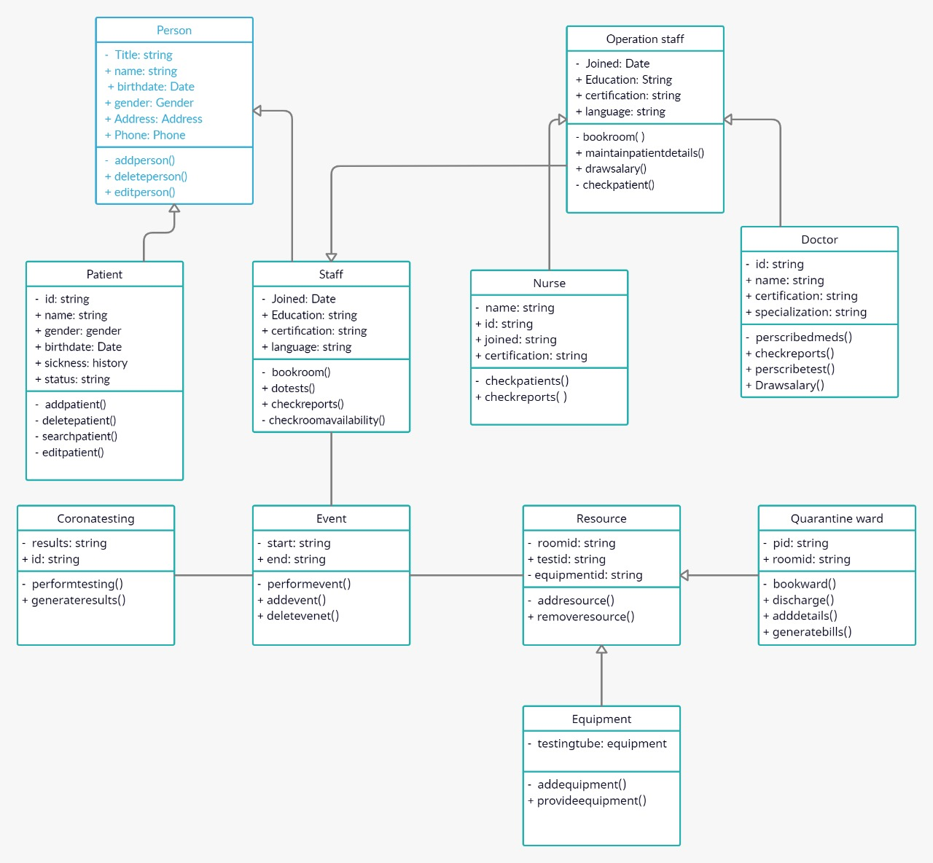

## Sequence Diagram

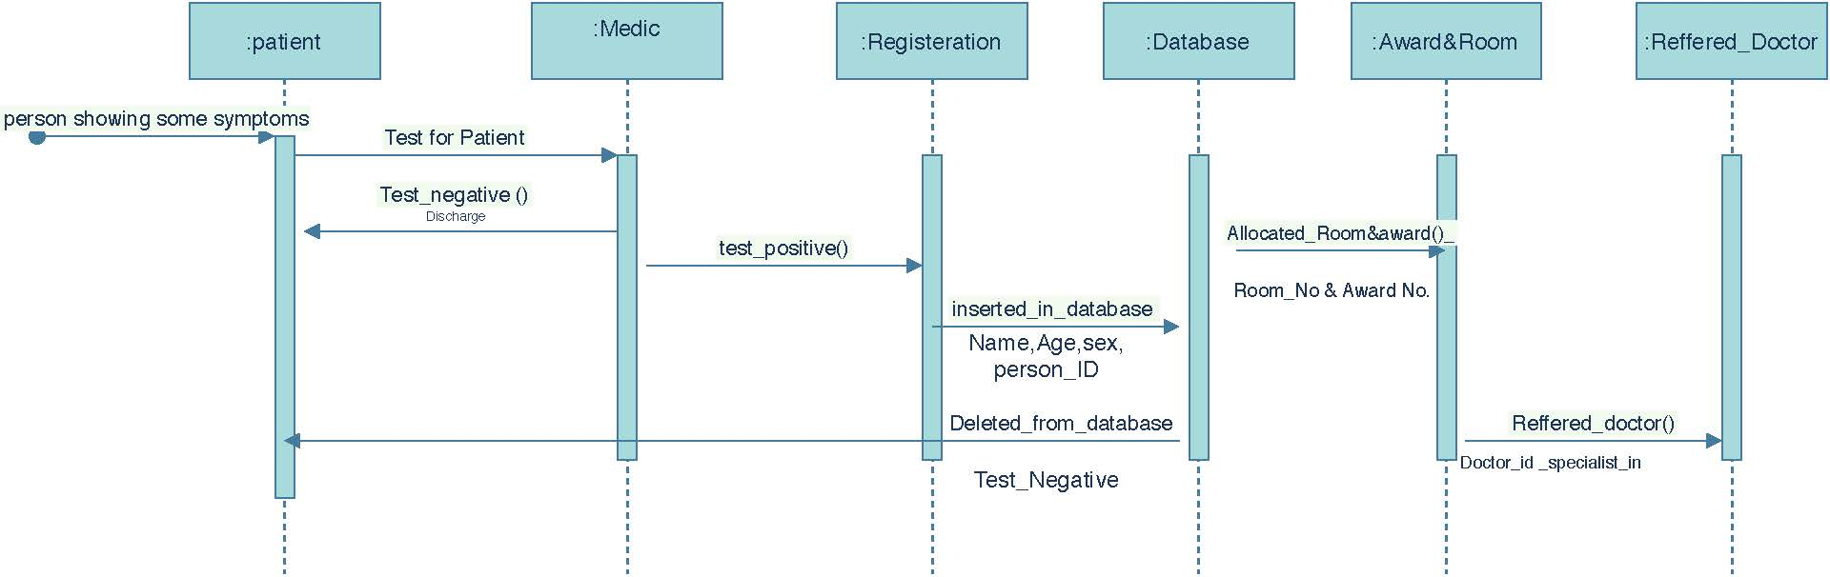

## Activity & Collaboration Diagram

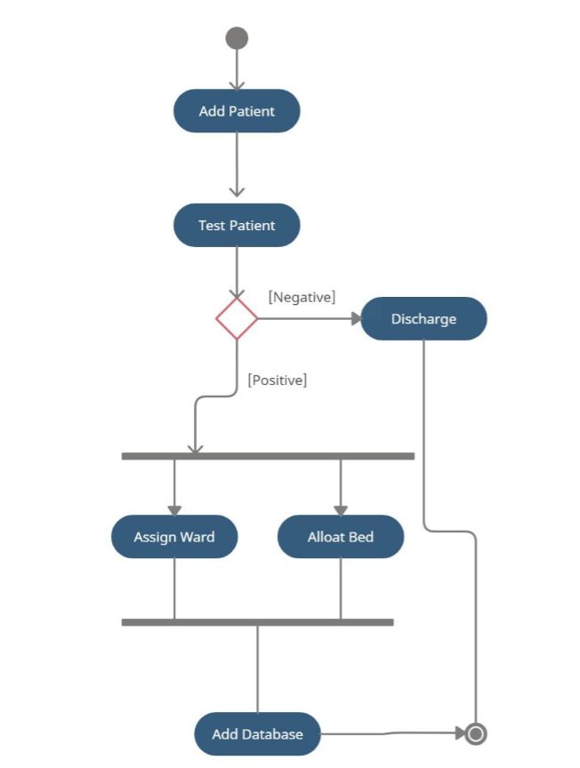

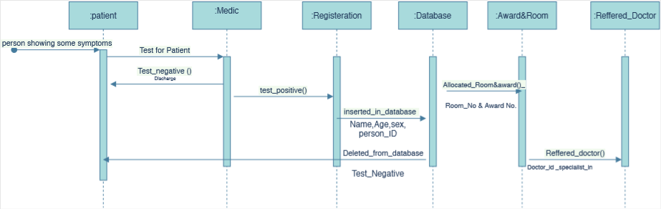

## State Chart Diagram

# Dependencies and Constraints

We will provide only the software for QMS and it is the responsibility of the client to set up suitable hardware for running the System. It is assumed that the Quarantine computers have updated web browsers such as Chrome and have internet server capabilities.

The Quarantine Management System shall be an independent system running in a Windows environment so we assume that user is using windows (8, 10). Otherwise if user use another operating system, there is a need of changing the SRS accordingly.

The requirements for the user interface is developed under the assumption that user is trained enough and have sufficient knowledge of computers and that the user knows English language, as the interface will be provided in English. The user is aware that the product can access Quarantine’s database.

# Cost and Pricing

Within 4 months of release, our experts will install QMS in our Quarantine Center.

The present financial constraints limit the cost to 600000 PKR. The suggested cost for installing QMS is 100,000 PKR. A one year maintenance contract is signed for each installation which is totally free of cost.

# Licensing and Installation

The product requires professional installation and it must be installed by licensed personnel only. Since the installation of Quarantine Management System is a complex process, our software professionals will do it for the user. The product is licensed only to the customers who buy QMS from us.

.